# 1.9 Source calibration system

Calibration and monitoring during data-taking is an important ingredient if the best possible performance of the calorimeter is to be realized. A suitable system must provide precise, independent crystal-by-crystal calibration. The use of radioactive sources is a proven technique for accomplishing such a calibration. However, most long-lived sources are limited to an energy around 1 MeV, which makes it difficult to secure a signal significantly above electronic noise, and sources that must be deployed individually are not practical with a system of ~2000 crystals. Mu2e has adopted an approach formerly devised for the BaBar electromagnetic calorimeter. In this system a 6.13 MeV photon line is obtained from a short-lived 16O transition that can be switched on and off arbitrarily. This system was successfully used for routine weekly calibrations of the BaBar calorimeter. It is an ideal match to the Mu2e requirements, and we have started the process of salvaging the BaBar system in order to refurbish it for use in Mu2e.

The decay chain producing the calibration photon line is*:*

The fluorine, a component of Fluorinert™ coolant liquid, is activated with a fast neutron source, producing the 16N isotope. This isotope then β-decays with a half-life of seven seconds to an excited state 16O*, which in turn emits a 6.13 MeV photon as it cascades to its ground state. A source spectrum collected with a BaBar CsI(Tl) crystal with PIN diode readouts is shown at right. There are three principal contributions to the overall energy distribution: one peak at 6.13 MeV, another at 5.62 MeV and a third at 5.11 MeV, the latter two representing e+e- annihilation photon escape peaks. Since all three peaks have well-defined energies, they simultaneously provide both an absolute calibration and a measure of the linearity of response at the low end of the calorimeter energy scale.

The fluorine is activated using neutrons provided by a commercial deuterium-tritium (DT) generator producing 14.2 MeV neutrons, at typical rates of several times 108 neutrons/second, by accelerating deuterons onto a tritium target. The DT generator is surrounded with a bath of the fluorine-containing liquid Fluorinert™, which is then circulated through a system of manifolds and pipes to the calorimeter crystals. Many suitable fluorine-containing liquids are commercially available; Fluorinert™ “FC-77” was used in BaBar and stored in a reservoir near the D-T generator. When a calibration run is started, the generator and a circulating pump are turned on. Fluid is pumped from the reservoir through the DT activation bath and then to the calorimeter. The system is closed, with fluid returning from the calorimeter to the reservoir. A schematic of the Mu2e system, based on the BaBar system, is shown below [NEED TO UPDATE FIGURE}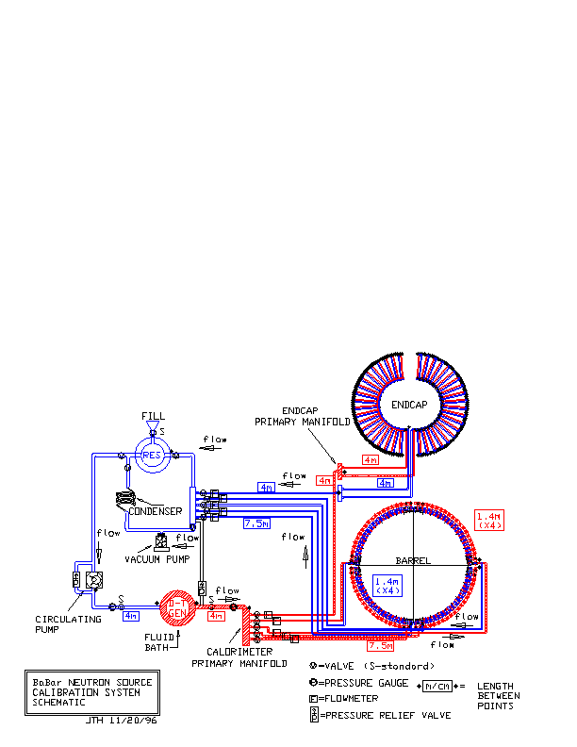.

The DT neutron generator is a small accelerator. Radiation safety protocols factor into the design of the calibration system, and operation of the source will be done remotely in a no-access condition. The half-life of the activated liquid is 7 seconds, and residual radioactivity is not a substantial concern when the DT generator is not operating. The DT generator produces 14 MeV neutrons, at a rate of several times 108 neutrons/second, and will be shielded according to FNAL safety regulations. The shielding will be interlocked such that the DT generator cannot be operated if the shielding is not in place. The fluid reservoir is capable of holding the entire volume of Fluorinert™ fluid required for operation of the system. In the event of a fluid leak, the maximum exposure for the BaBar system was calculated to result in a maximum integrated dose of less than 1 mrem; for Mu2e, a detailed hazard analysis will be performed in collaboration with FNAL radiation safety experts. Operation of the system is anticipated to be approximately weekly during Mu2e running.

In BaBar, the fluid was pumped at 3.5 liter/second, producing a counting rate of ~40 Hz in each of the ~6500 BaBar crystals, which were an average distance of about 12 m from the DT generator. This produced a calibration with a statistical uncertainty of ~0.35% on peak positions in a single crystal in a 10-15 minute calibration run. The fluid transport manifold consisted of thin-wall (0.5 mm) aluminum tubing (3/8-inch diameter); 1 mm of Al represents 1.2% of a radiation length. The tubes were placed in front of the BaBar crystals, with an additional 2 mm of Al in the structural support for the tube assemblies. A similar system of thin-wall aluminum tubing mounted on a supporting structure will be implemented for each of the two Mu2e calorimeter disks.

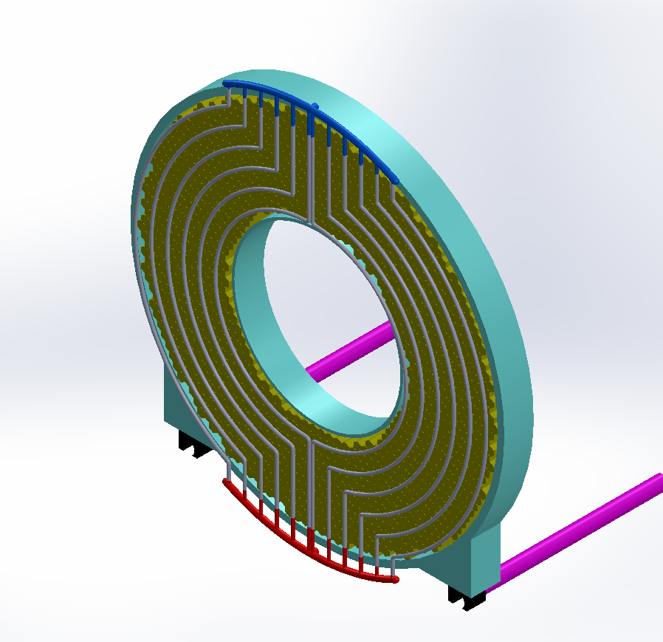

The figure at the right shows the layout of Al pipes at the front face of a calorimeter disk, along with the manifolds at bottom (red) and top (blue) that lead to and from the fluid activation bath. Studies using as a figure-of-merit the number of photons passing through a surface element at the front face of a crystal have been performed to optimize the spacing between pipes and the perpendicular distance from the pipes to the front surface of the crystals. The figure at left below demonstrates the ±10% variation in illumination as a function of increasing radial distance for an inter-pipe spacing of 60 mm and 30 mm between pipes and the front surface of the crystals. The figure at right below shows the relative intensity for different values of the distance between pipes and the crystal front surface as a function of radial distance. Based on these studies,we have chosen to set the distance between pipes to 60 mm, which essentially allows one pipe to pass between every other crystal. The distance from the pipes to the crystal front surface should be minimized but, as can be seen from the figure, any distance between approximately 10-30 mm is reasonable. The final value for the perpendicular distance will be determined within this window taking into account any engineering constraints.

## Salvage of System Components from SLAC

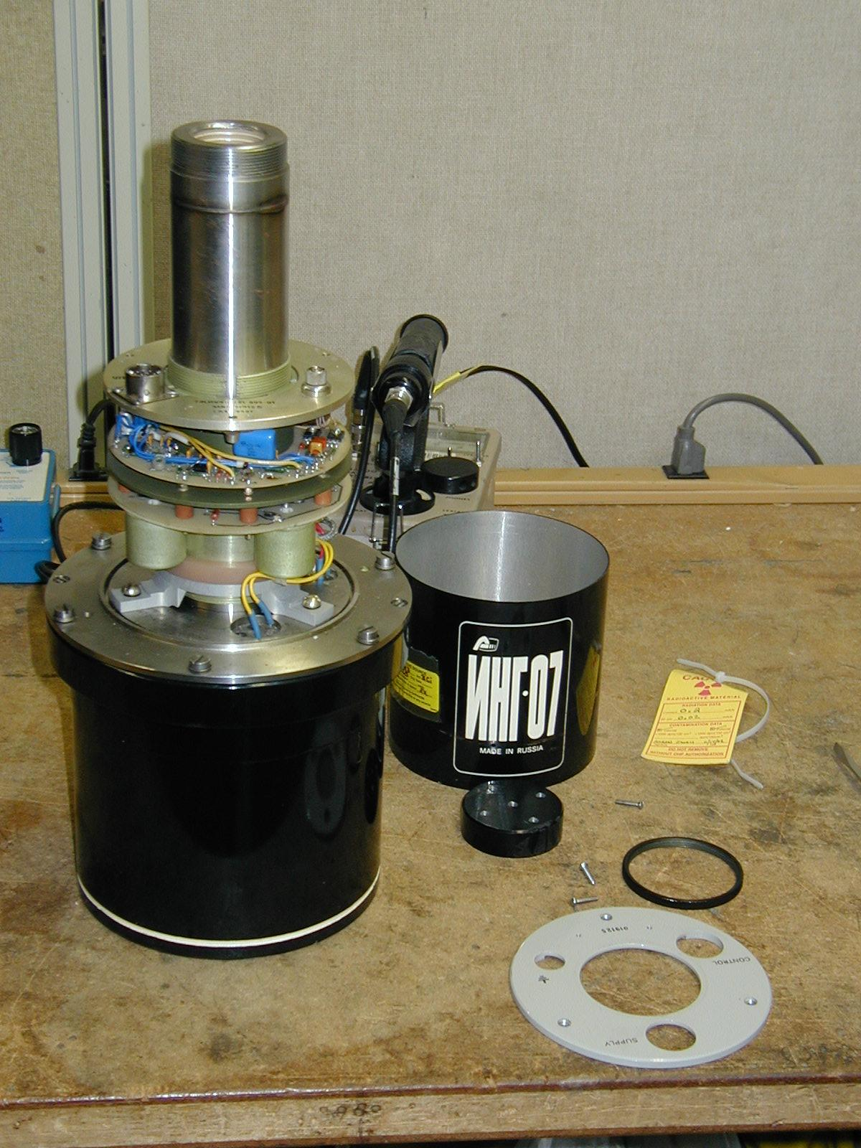Many of the main components of the source calibration system used at BaBar have been preserved in good condition during the BaBar detector decommission process and have been requested from SLAC. These items include:

* the BaBar DT generator, model ING-07, manufactured by the All-Russia Institute of Automatics (shown partially disassembled prior to installation at BaBar in the photo at the right) , including HV power supply, PC-interface controller card and cabling;
* elements of the fluid distribution system, including the primary outgoing and incoming manifolds, valves and pressure gauges, and the main distribution panel on which many of these items are mounted;
* pumps for the fill and fluid activation loops; and
* any remaining stocks of Fluorinert™ FC-77.

